System Architecture
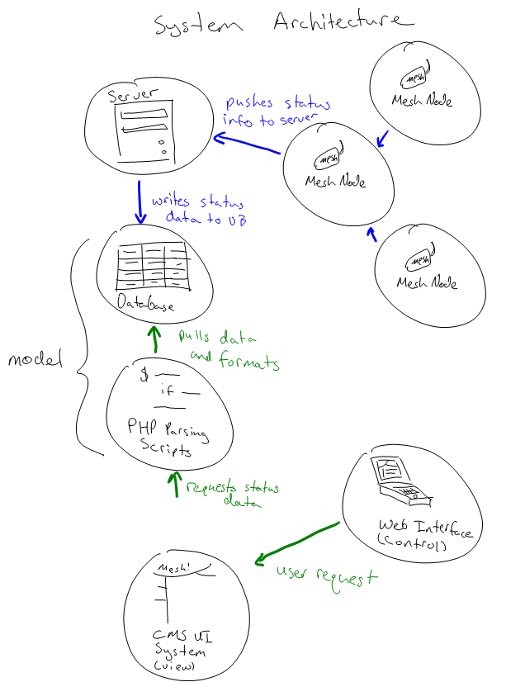
Above is the architecture for the complete OrangeMesh system. Data regarding network statistics is pushed on a regular (~5 min.) from the nodes, through the mesh network, to the dashboard server. That information is recorded in the database for later processing.
Upon receiving a request from a user, the content management system calls the OrangeMesh scripts that parse data in the database. These scripts then generate whatever content was requested by the user and the entire package is served to the user.
This project focuses on developing the PHP scripts and CMS. Generating the network status is handled by the ROBIN project.

